Smart Internship Management System

Group Members:
Munazza Sana | BSCS-A
Zarmeen Qasim | BSCS-A

Milestone Tracking:
Milestones | Date | Version | Remarks
ERD Diagram and Schema | 24/4/2026 | 1.0

Entity Relationship Diagram (ERD):

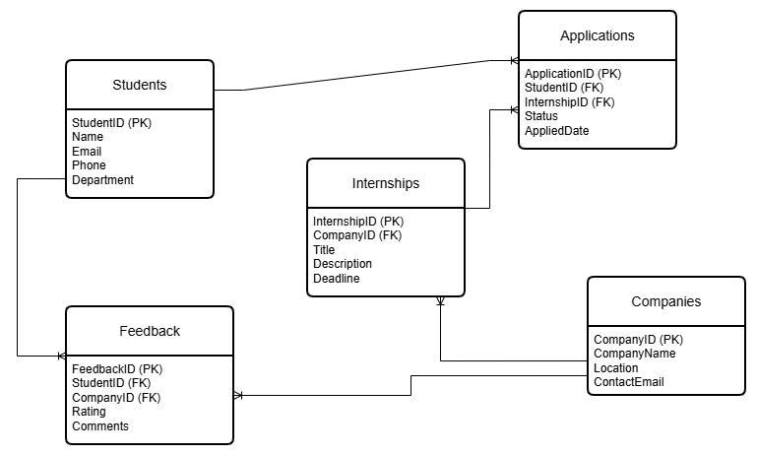

Relational Database Schema Description:

1. Students Table
Attributes:
- StudentID (Primary Key)
- Name
- Email
- Phone
- Department

2. Companies Table
Attributes:
- CompanyID (Primary Key)
- CompanyName
- Location
- ContactEmail

3. Internships Table
Attributes:
- InternshipID (Primary Key)
- CompanyID (Foreign Key)
- Title
- Description
- Deadline

4. Applications Table
Attributes:
- ApplicationID (Primary Key)
- StudentID (Foreign Key)
- InternshipID (Foreign Key)
- Status
- AppliedDate

5. Feedback Table
Attributes:
- FeedbackID (Primary Key)
- StudentID (Foreign Key)
- CompanyID (Foreign Key)
- Rating
- Comments

Relationships:
- One Student can submit many Applications (1:M)
- One Internship can receive many Applications (1:M)
- One Company can post many Internships (1:M)
- One Student can give many Feedback entries (1:M)
- One Company can receive many Feedback entries (1:M)

